

the comPuterization of biT, deoghar

Assignment 2



September 19, 2021

Priyanka Marandi

BTECH/60094/19

**SEQUENCE DIAGRAM**

**THE COMPUTERIZATION OF BIT, DEOGHAR**

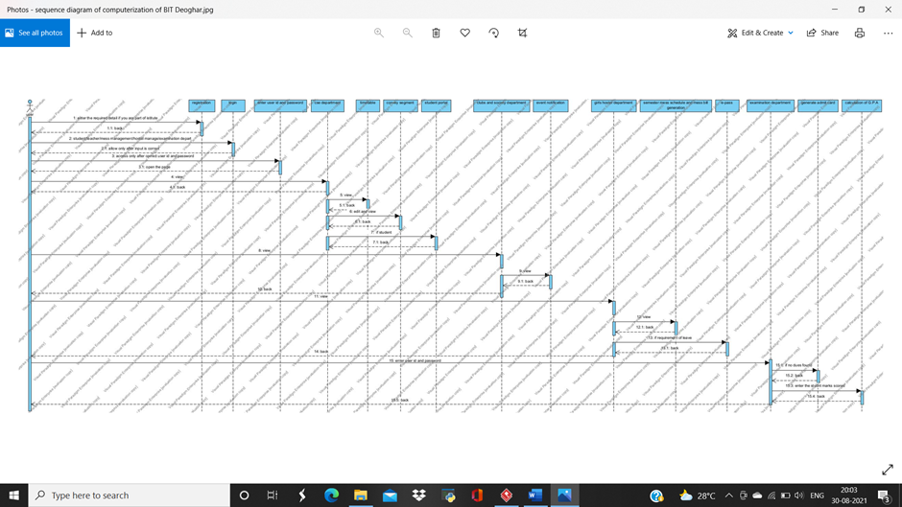

**MODULE 01: COMPUTER SCIENCE AND ENGINEERING DEPARTMENT**

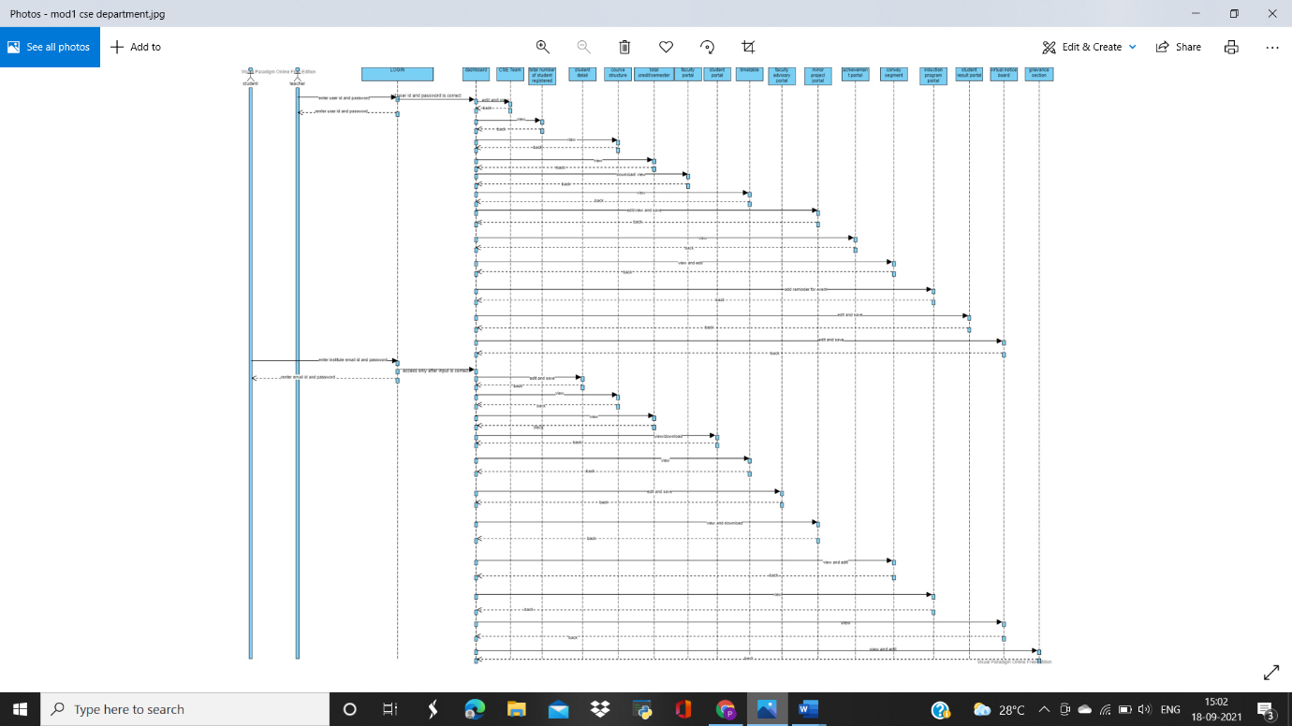

**MODULE 02: CLUBS AND SOCIETY DEPARTMENT**

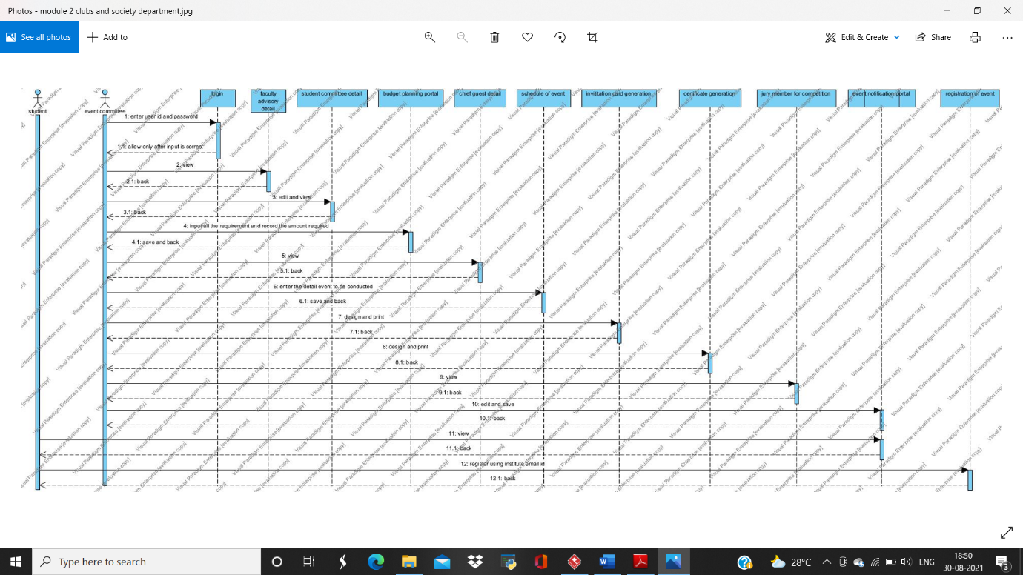

**MODULE 03: GIRL’S HOSTEL DEPARTMENT**

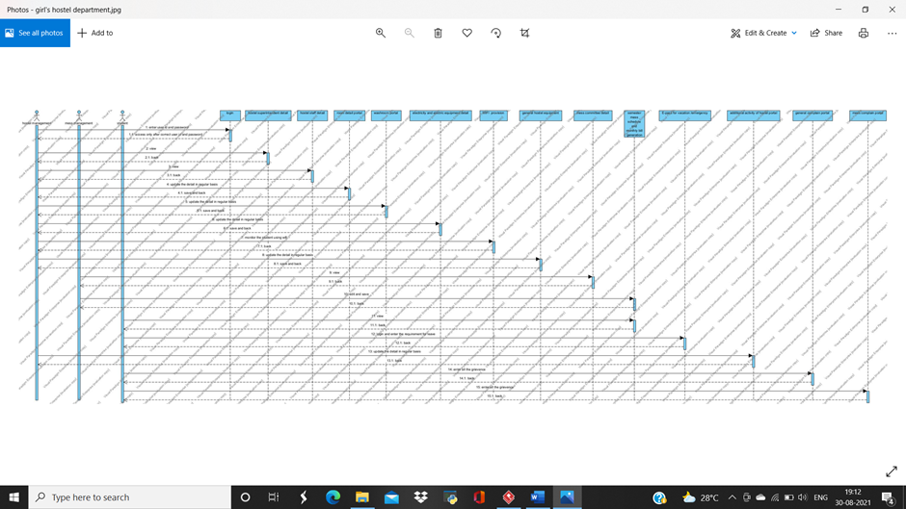

**MODULE 04: EXAMINATION DEPARTMENT**

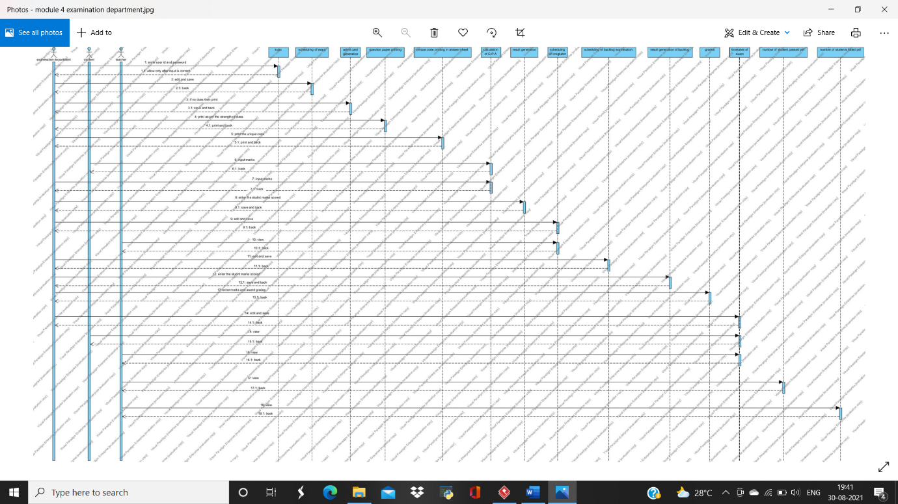

**CLASS DIAGRAM**

**MODULE 01: COMPUTER SCIENCE AND ENGINEERING DEPARTMENT**

**INDEPENDENT CLASS DIAGRAM**

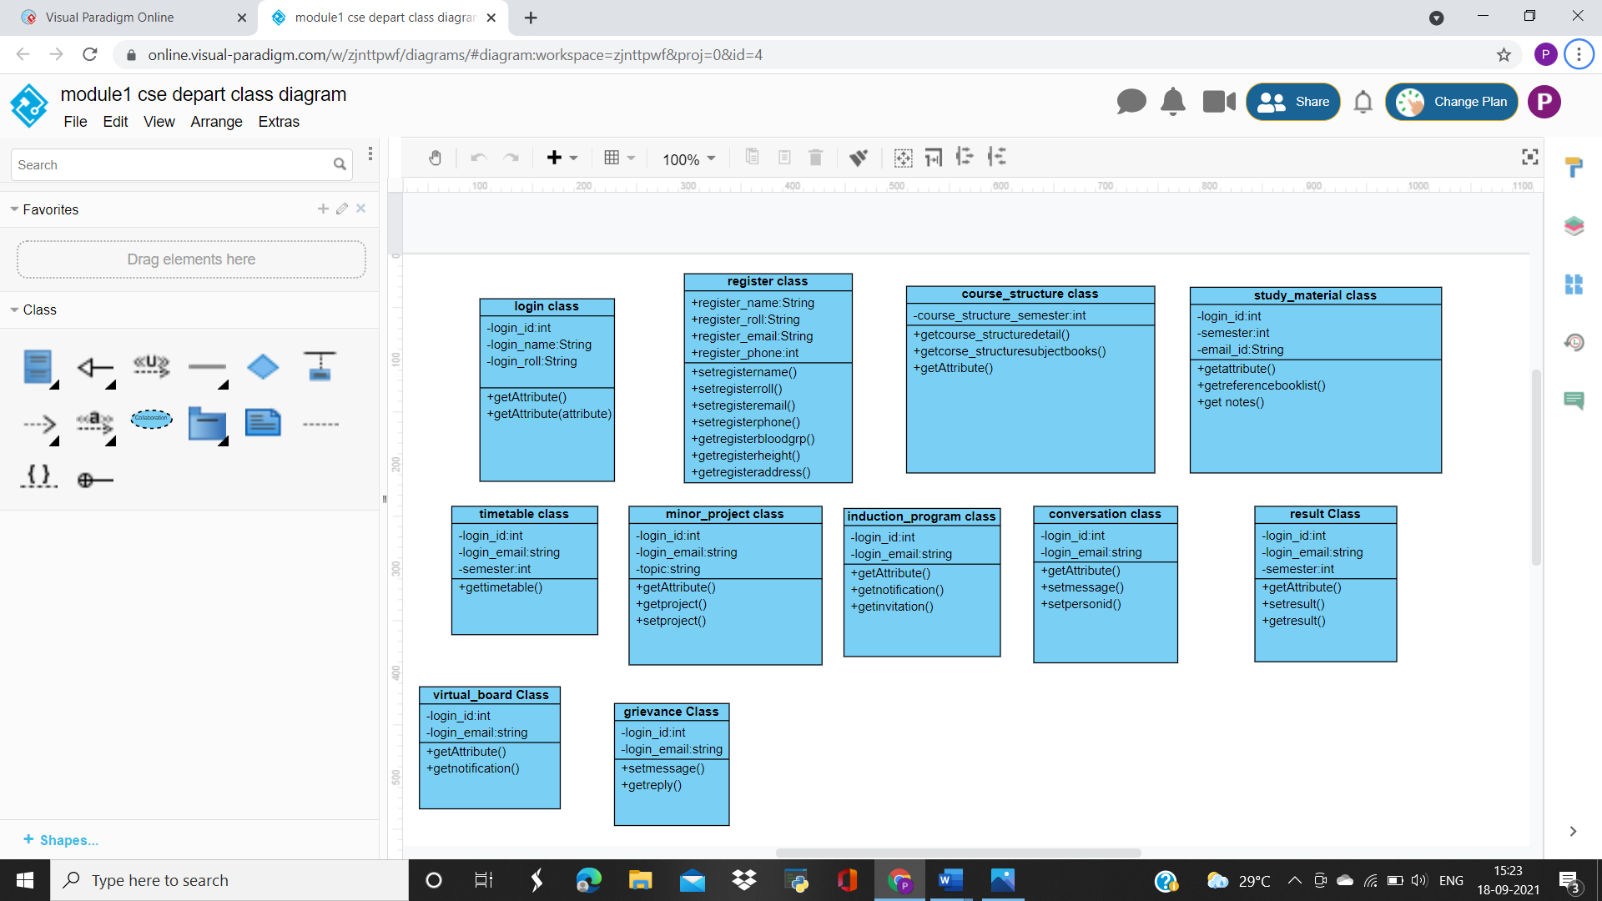 **Fig: login class**

**fig: registration class**

**fig: course structure class**

**fig: study material class**

**fig: timetable class**

**fig: minor project class**

**fig: induction program class**

** fig: conversation class**

**fig: result class**

**fig: virtual notice board**

**fig: grievance class**

**SUPERCLASS AND SUBCLASS DIAGRAM**

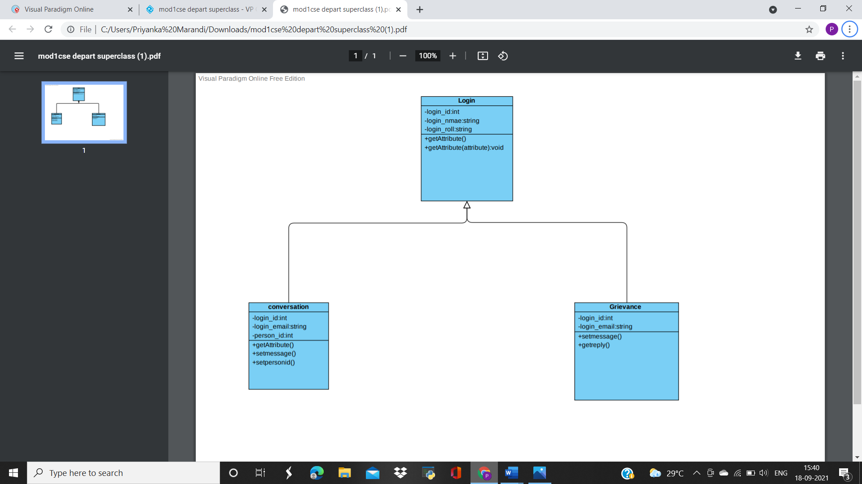

**ASSOCIATION DIAGRAM**

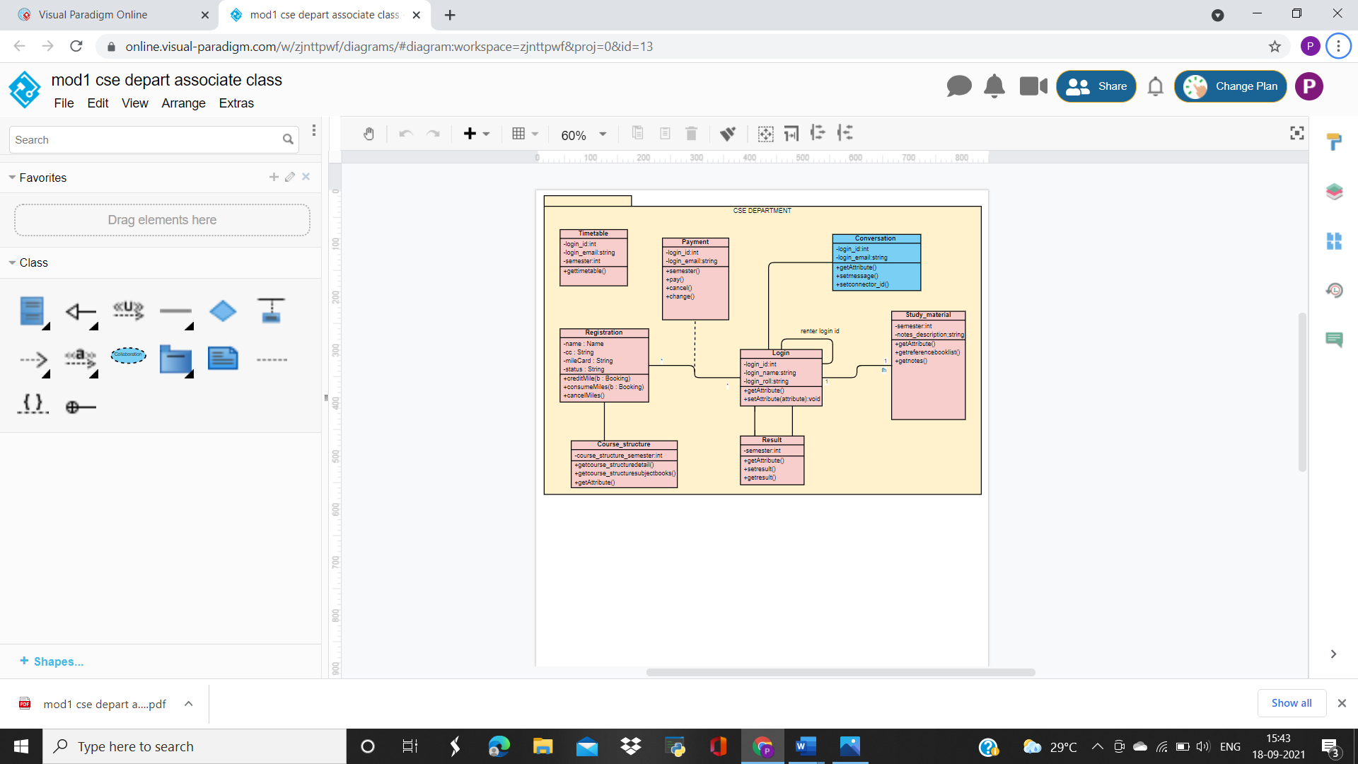

**MODULE 02: CLUBS AND SOCIETY DEPARTMENT**

**INDEPENDENT CLASS DIAGRAM**

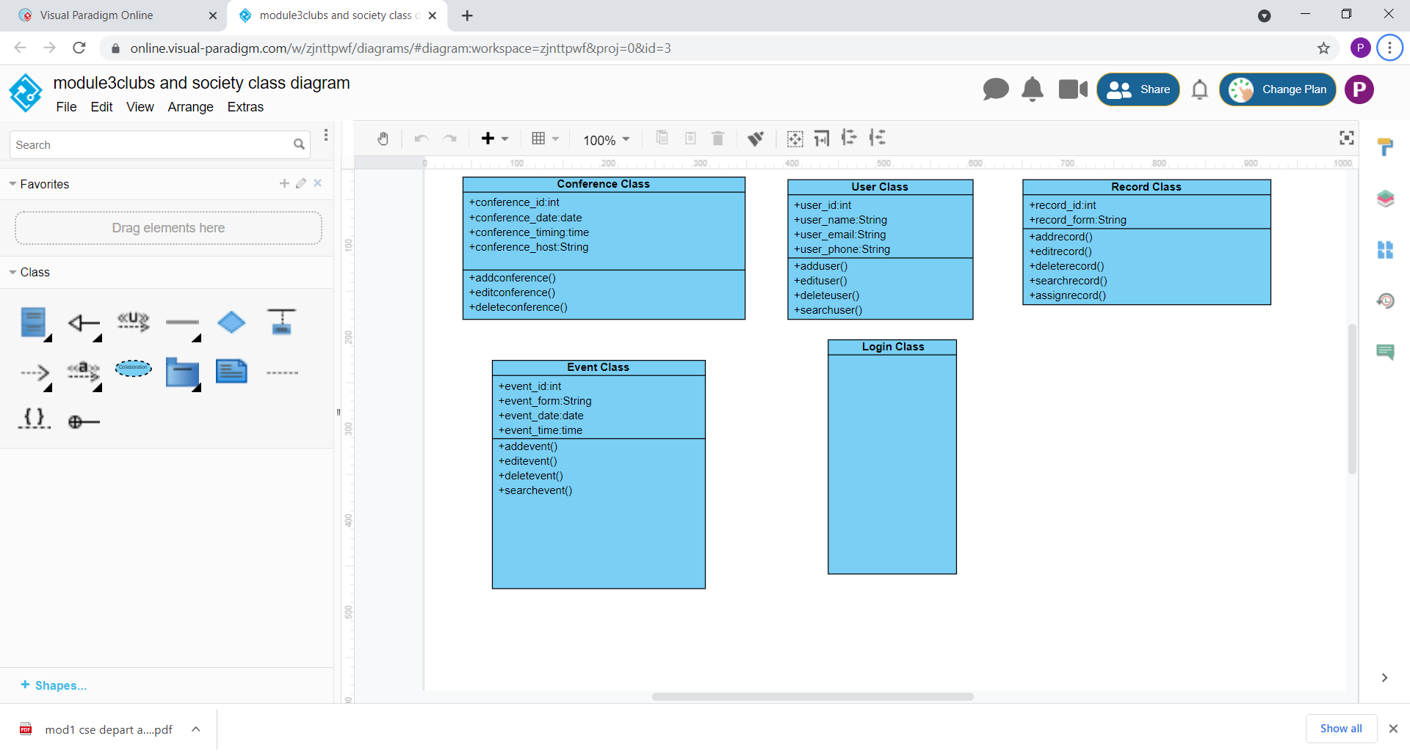**fig: event class**

**fig: user class**

**fig: conference class**

**fig: record class**

**SUPERCLASS AND SUBCLASS DIAGRAM**

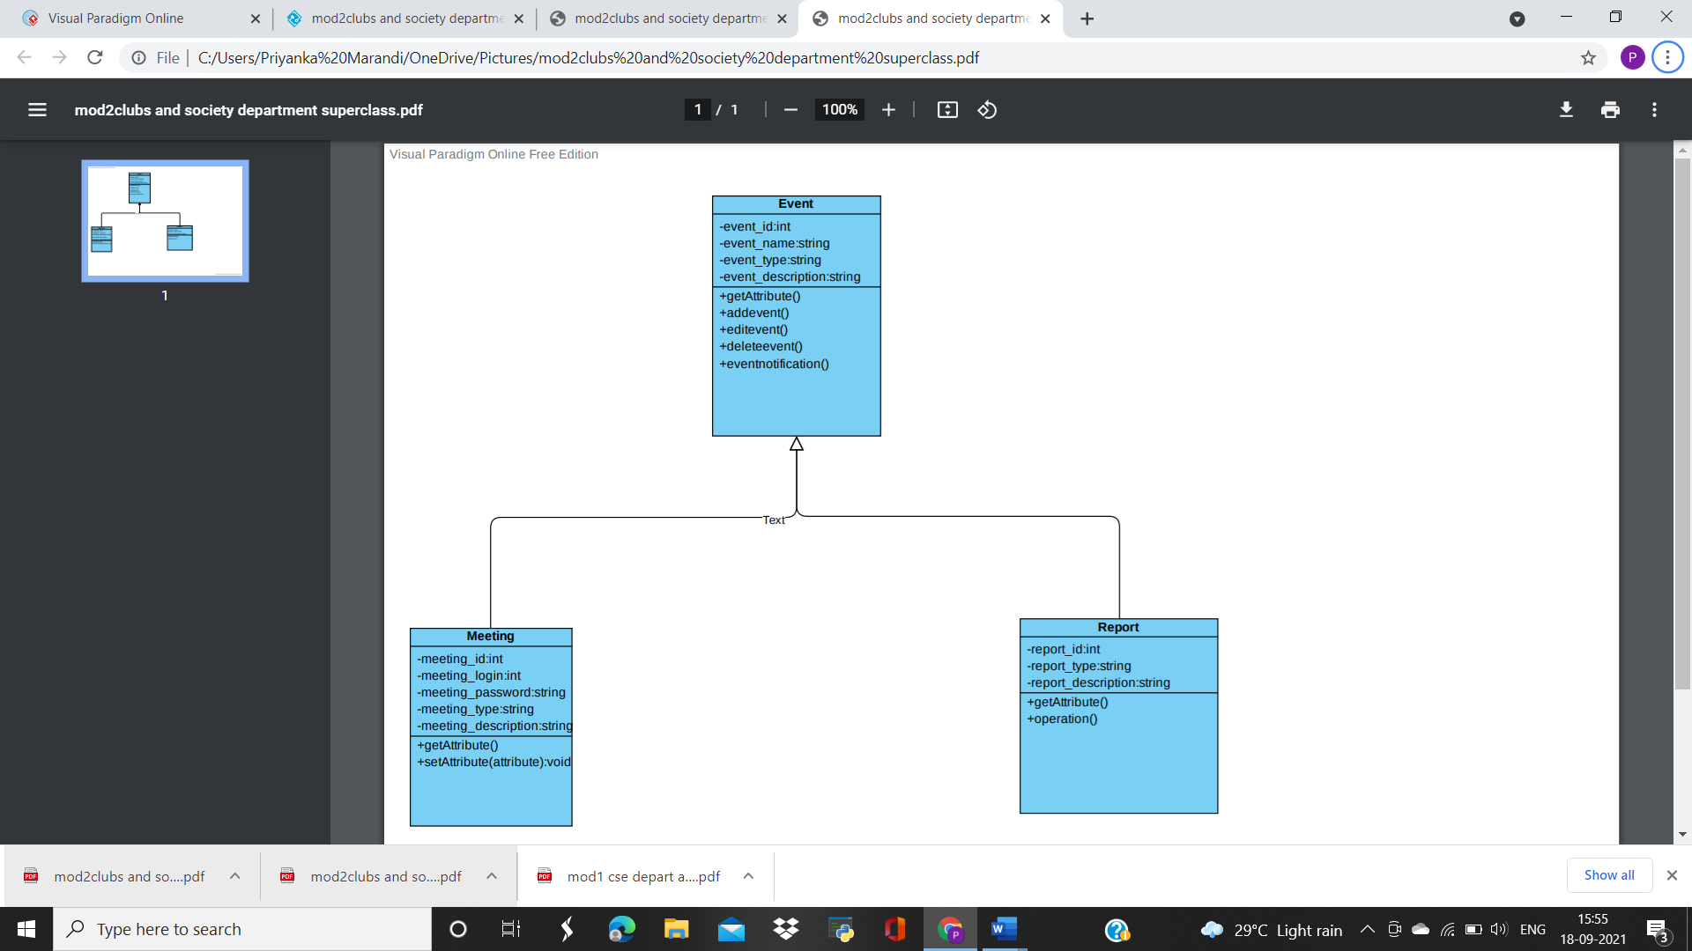

**ASSOCIATION DIAGRAM**

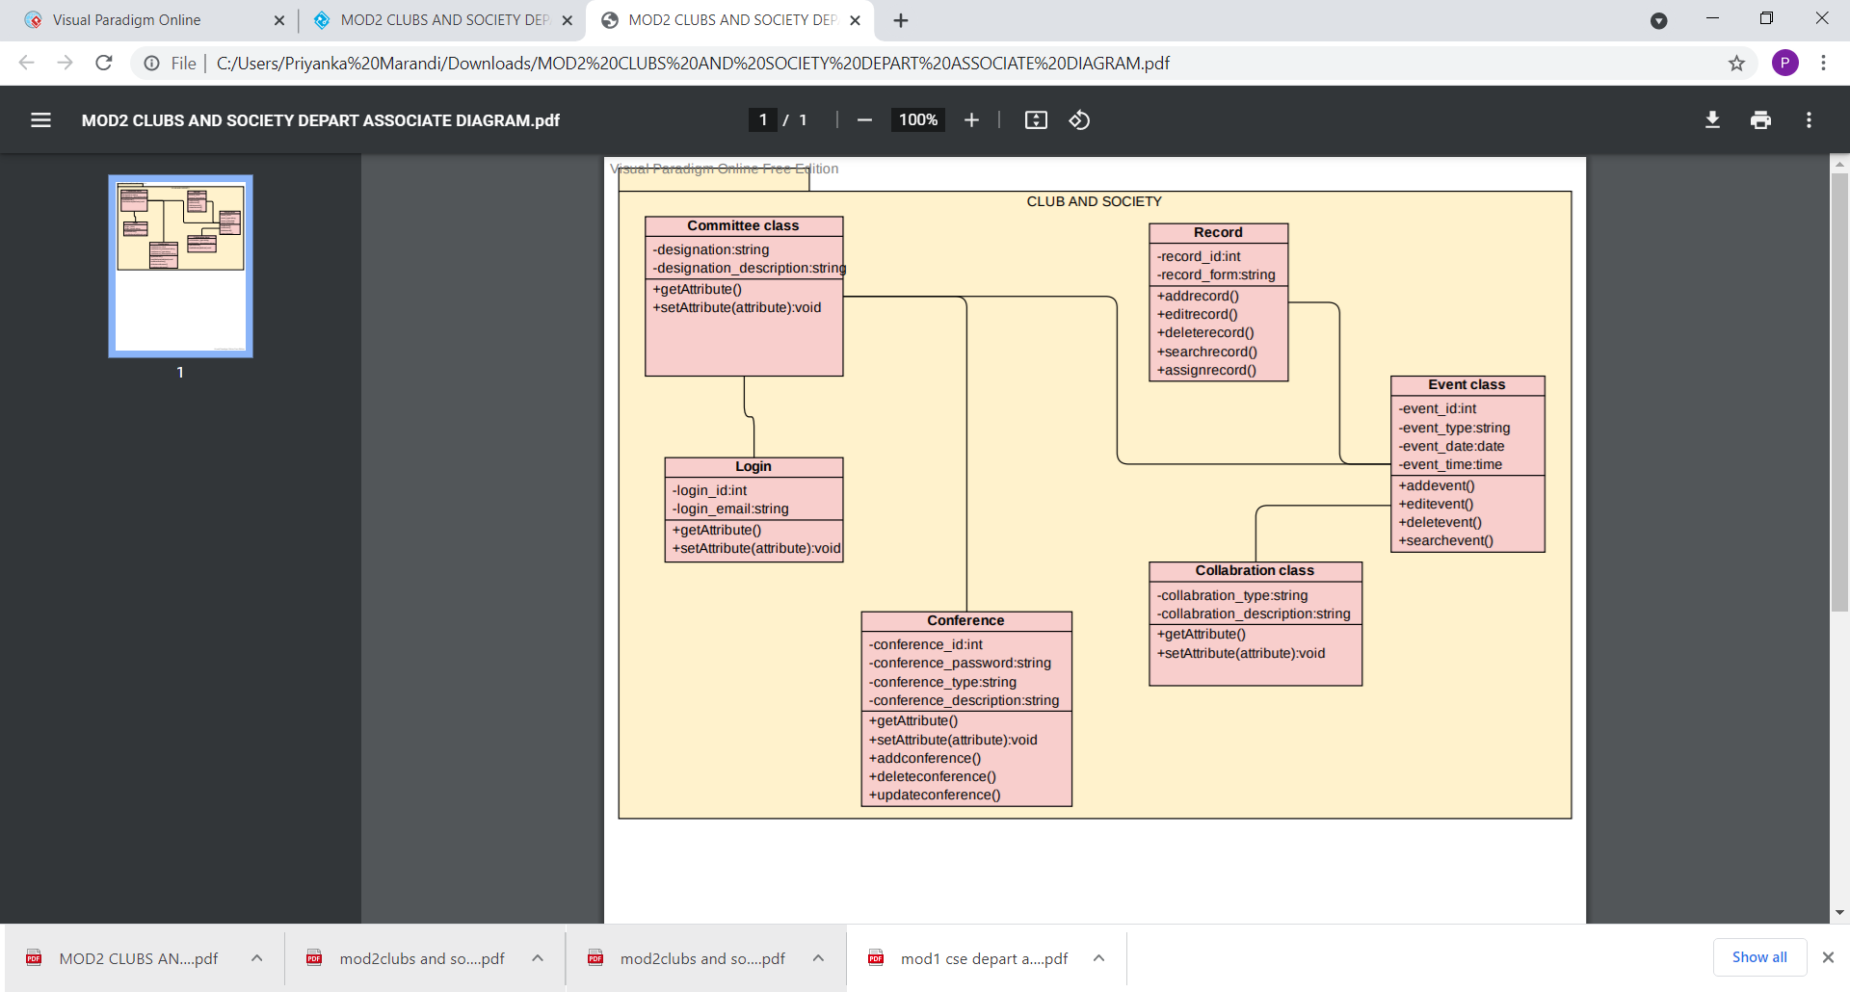

**MODULE 03: GIRL’S HOSTEL DEPARTMENT**

**INDEPENDENT CLASS DIAGRAM**

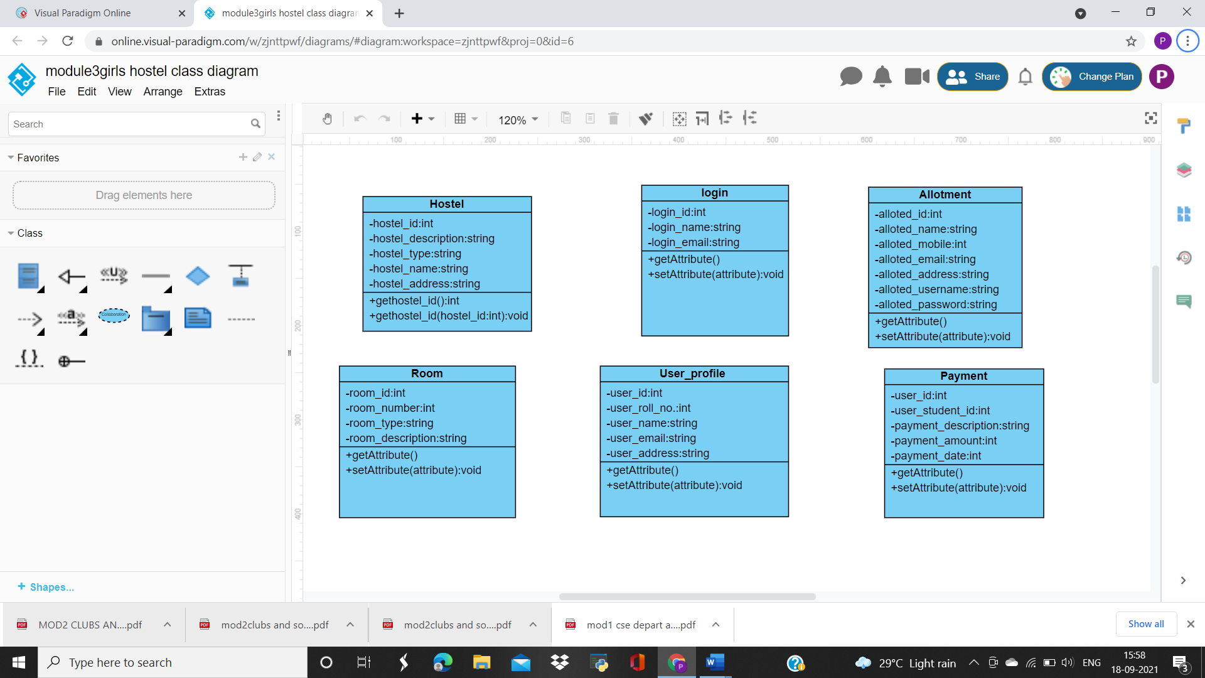**fig: user profile class**

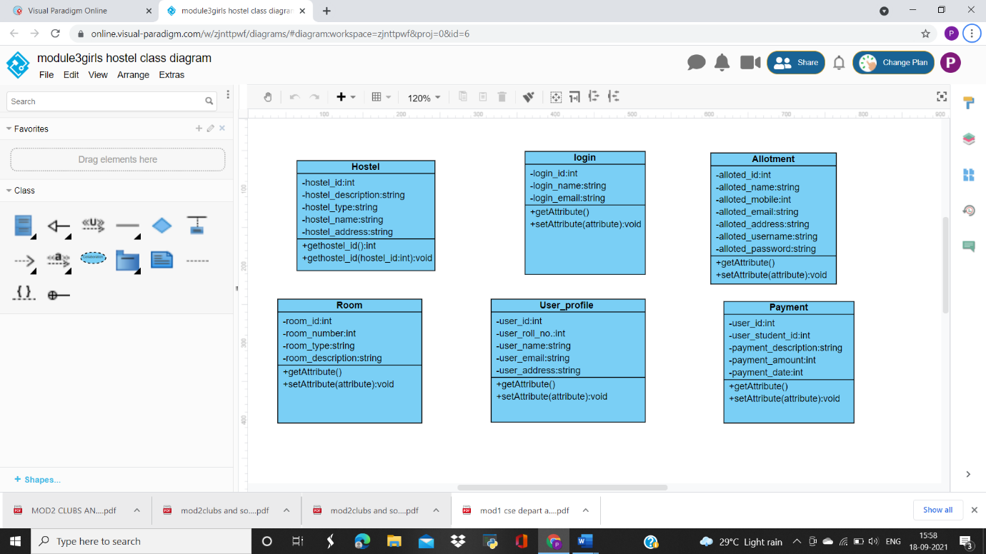**fig: login class**

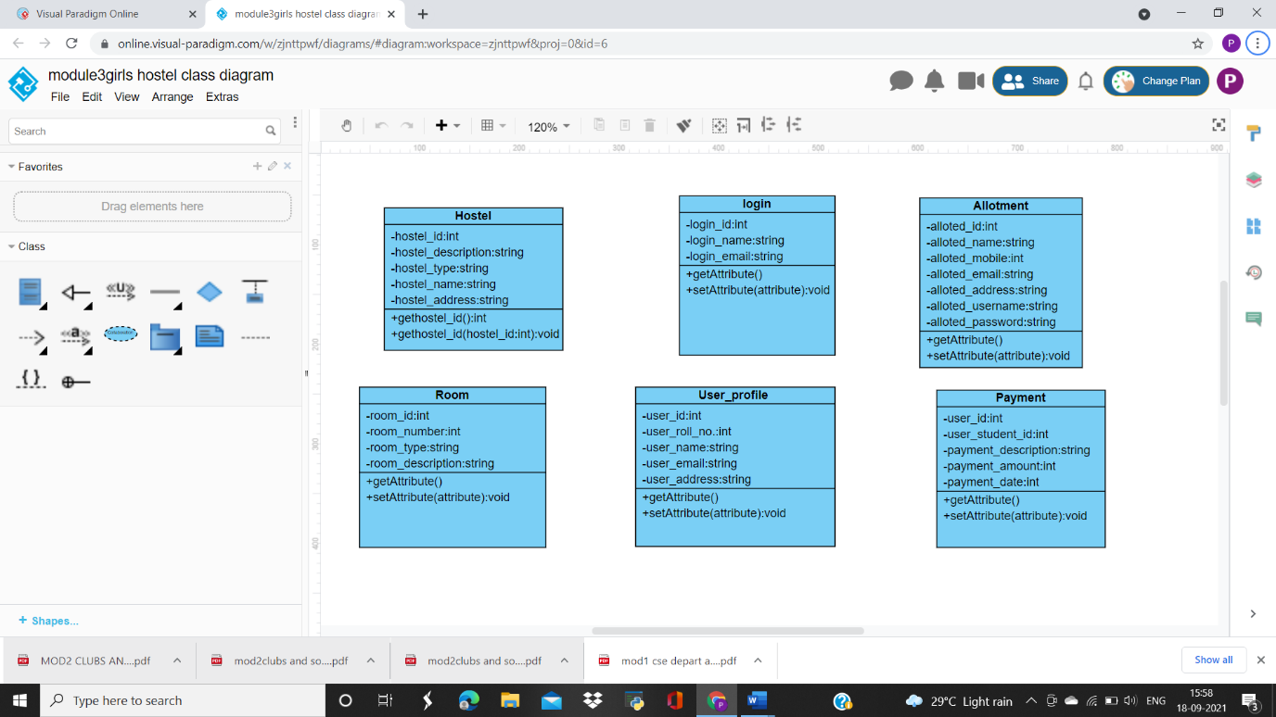**fig: hostel class**

**fig: allotment class**

**fig: room class**

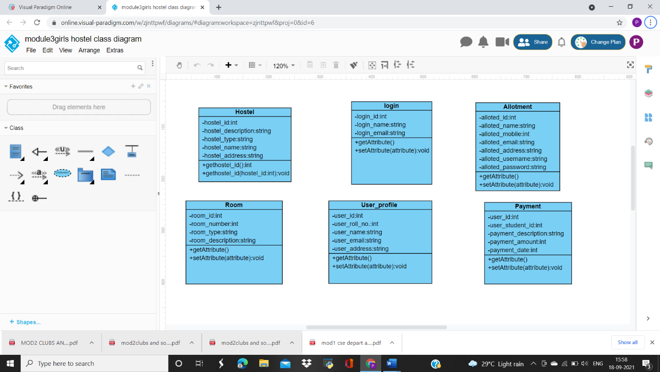**fig: payment class**

**SUPERCLASS AND SUBCLASS DIAGRAM**

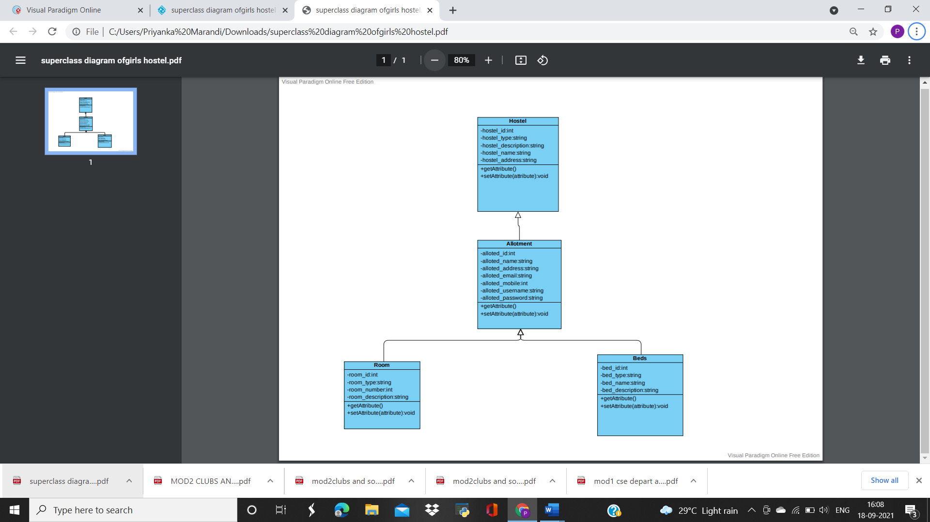

**ASSOCIATION DIAGRAM**

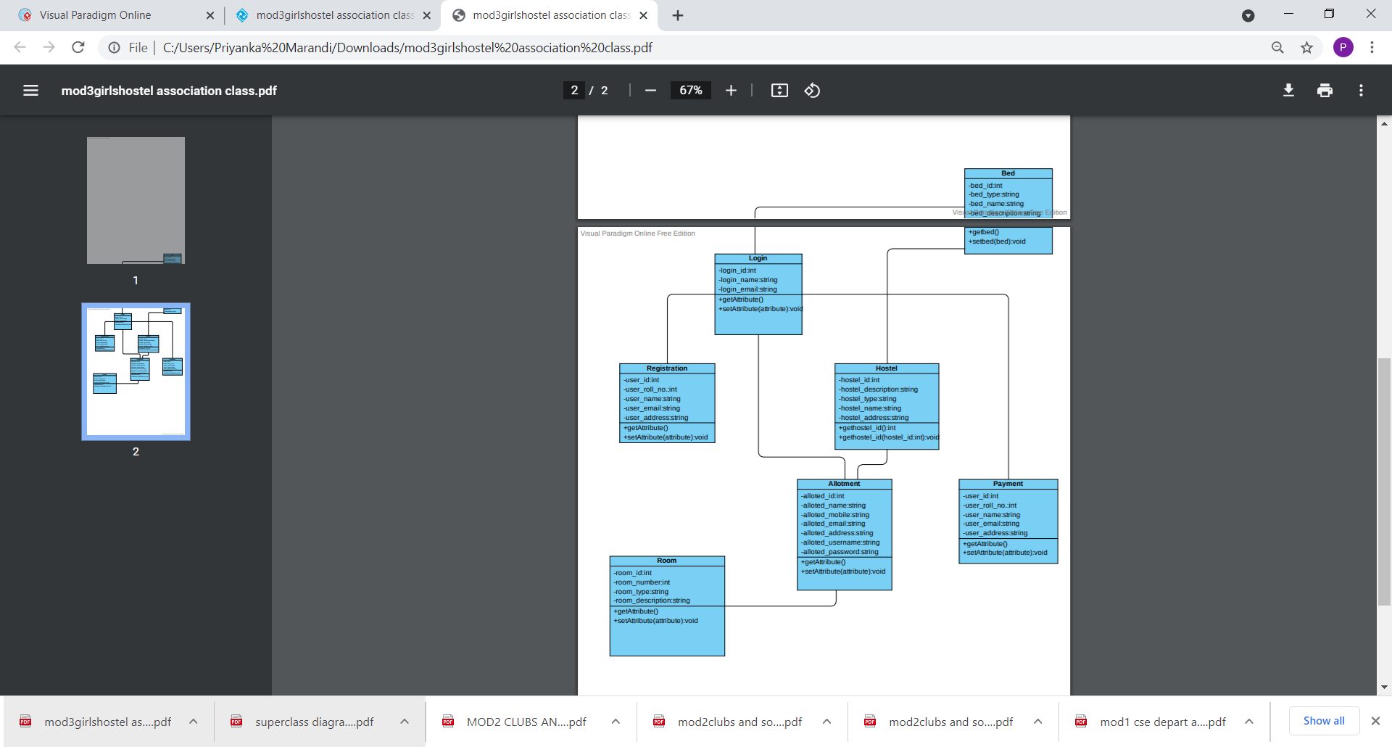

**MODULE 04: EXAMINATION DEPARTMENT**

**INDEPENDENT CLASS DIAGRAM**

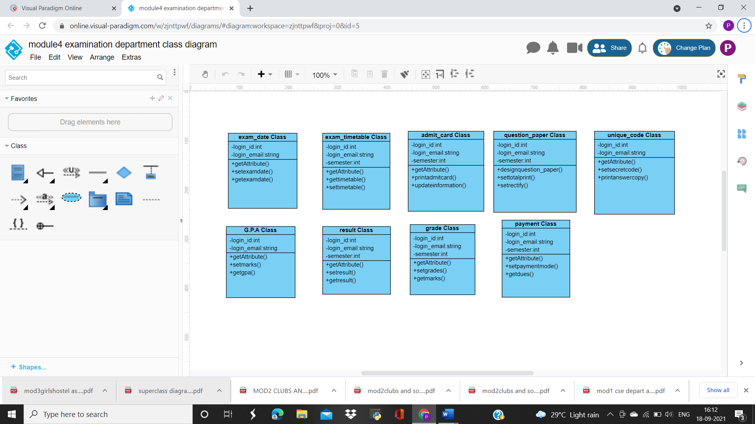 **fig: exam date class**

**fig: timetable class**

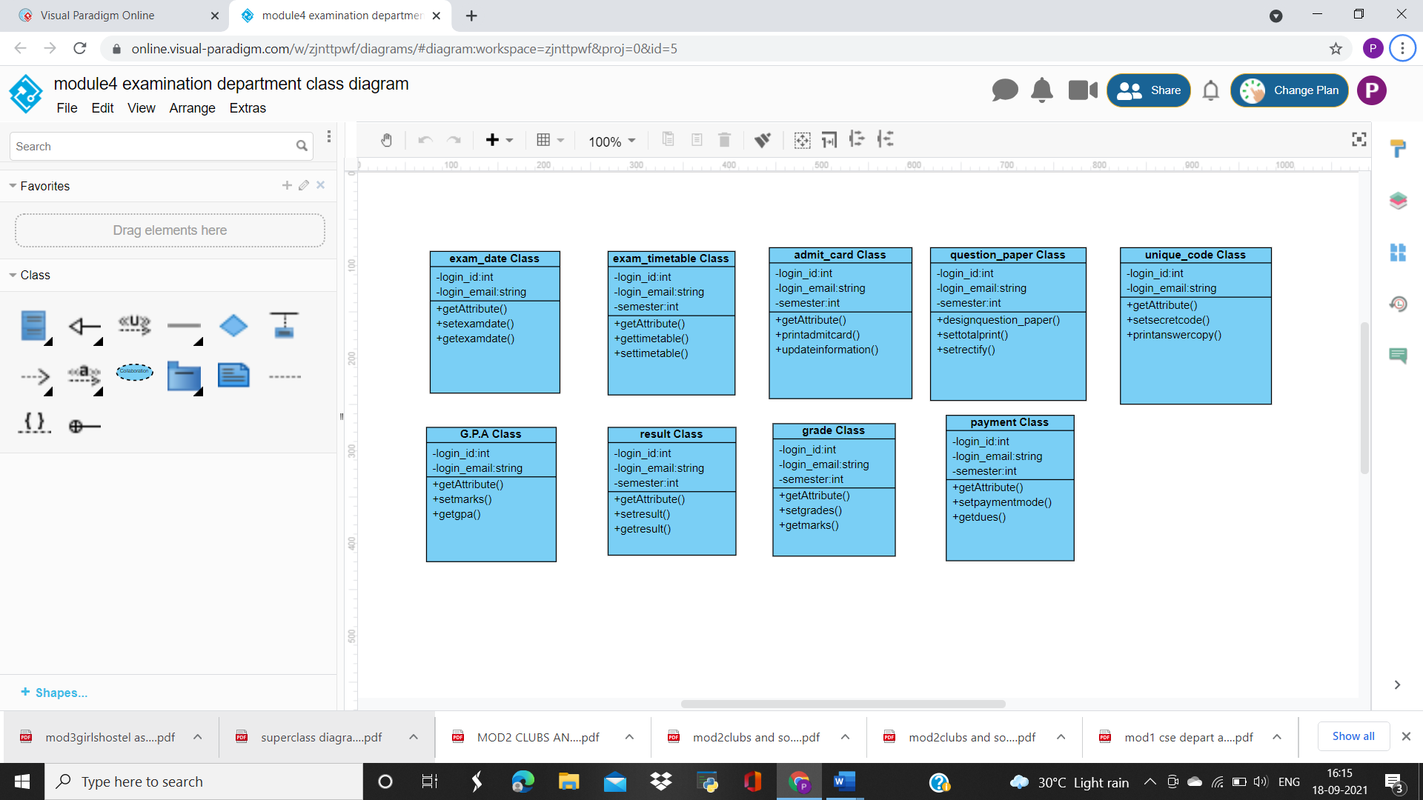**fig: admit card class**

**fig: question paper class**

**fig: unique code class**

**fig: result class**

 f**ig: grade class**

**fig: G.P.A class**

**fig: payment class**

**SUPERCLASS AND SUBCLASS DIAGRAM**

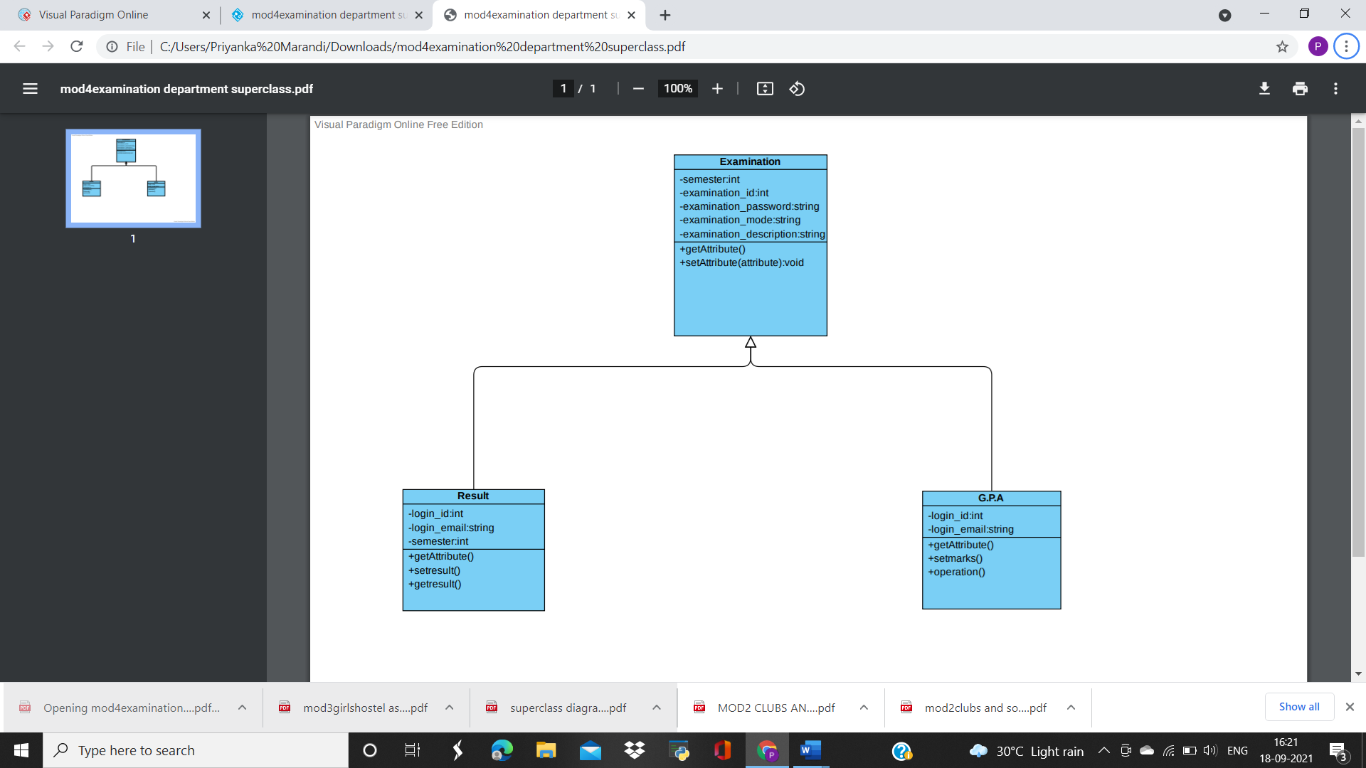

**ASSOCIATION DIAGRAM**

